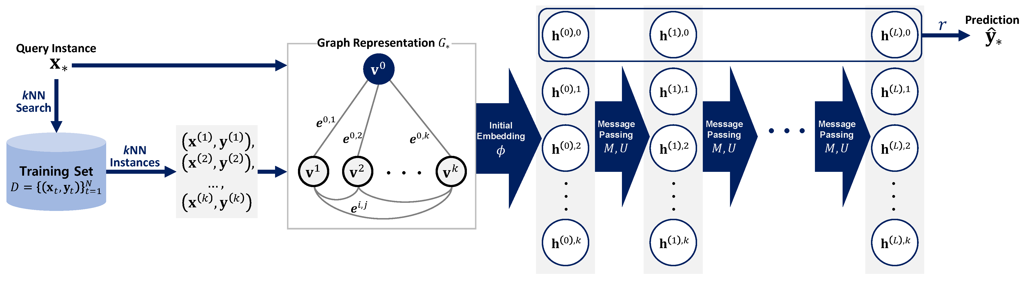

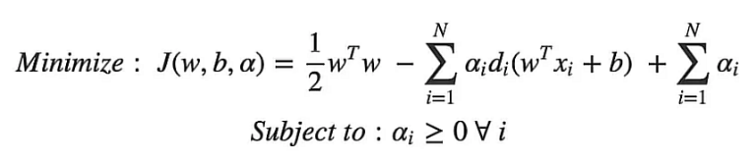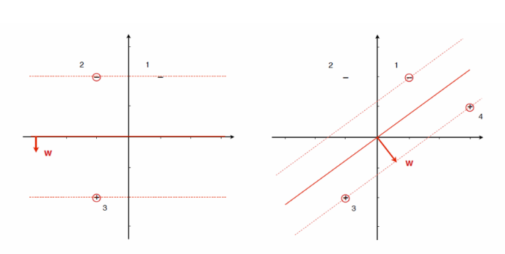

**UTILIZING THE SVM MODEL FOR ATTACK DETECTION AND APPLYING THE RYU AND ONOS CONTROLLERS TO BLOCK THE ATTACK**

